**Academic Year: 2024-25 Semester: V**

**Class / Branch: TEIT Subject: DevOps Lab**

**Name of Instructor: Ms. Sujata Oak/ Ms. Sonal Jain**

# Experiment No. 2

**Aim: To perform installation of Git and work on local and remote Git repositories.**

GIT is a Version Control System (VCS) (aka Revision Control System (RCS), Source Code Manager (SCM)). A VCS serves as a Repository (or repo) of program codes, including all the historical revisions. It records changes to files at so-called commits in a log so that you can recall any file at any commit point.

To issue a command, start a "Terminal" (for Ubuntu/Mac) or "Git Bash" (for Windows):

$ **git <command> <arguments>**

The commonly-used commands are:

1. **init**, **clone**, **config**: for starting a Git-managed project.
2. **add**, **mv**, **rm**: for staging file changes.
3. **commit**, **rebase**, **reset**, **tag**:
4. **status**, **log**, **diff**, **grep**, **show**: show status
5. **checkout**, **branch**, **merge**, **push**, **fetch**, **pull**

#### **Getting Started with Local Repo**

There are 2 ways to start a Git-managed project:

1. Starting your own project;
2. Cloning an existing project from a GIT host.

Git uses two stages to commit file changes:

1. "git add <file>" to stage file changes into the staging area, and
2. "git commit" to commit ALL the file changes in the staging area to the local repo.

**You need to setup Git on your local machine, as follows:**

**To update all local package index for ubuntu:**

$sudo apt update



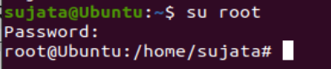

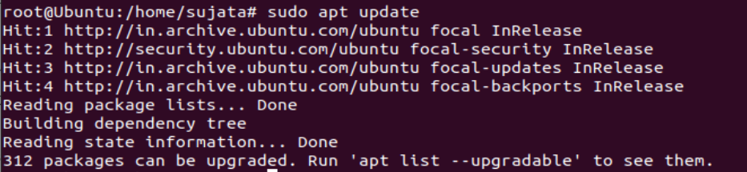

**Step1:** Download & Install:

* For Ubuntu, issue command "sudo apt-get install git".
* #apt install git

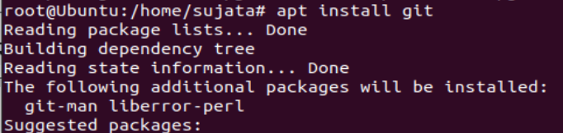

To check version of git:

#git –version



**Step 2**: Customize and configure your Git Account:

#git config --global user.name “sujataoak799”



#git config --global user.email [sujataoak2021@gmail.com](mailto:sujataoak2021@gmail.com)



To List Global configuration for Git:

#git config --list

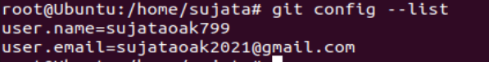

**Step . 3**

To Integrate Git account with Github:

**Goto** [**www.github.com**](http://www.github.com)

Sign-in to your account

Create a Repository

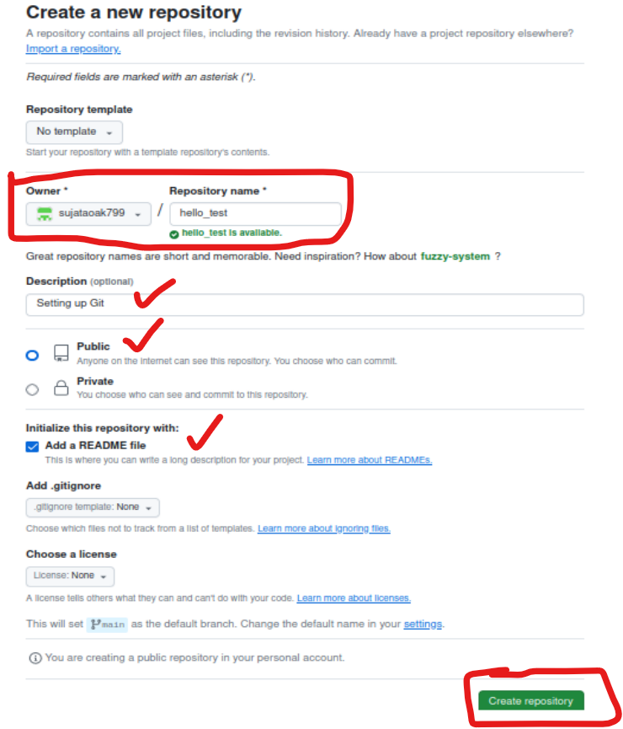

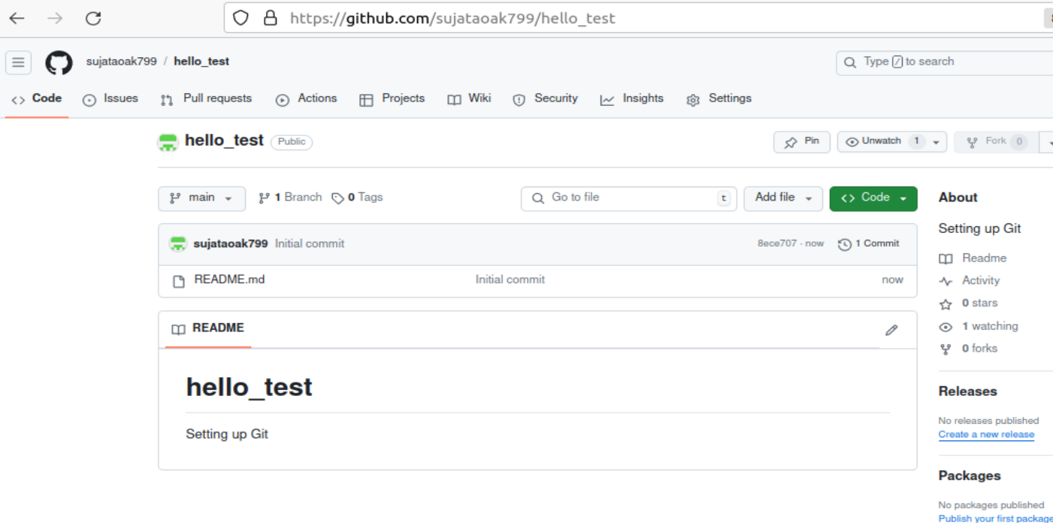

**Step . 3**

Now Clone the Remote Repository into your Local Repository ie; Ubuntu Operating System:

Firstly create a workspace:

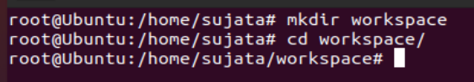

* Initiate that directory to make it a git repository (.git file must be added inside that folder after initiation)

#git init



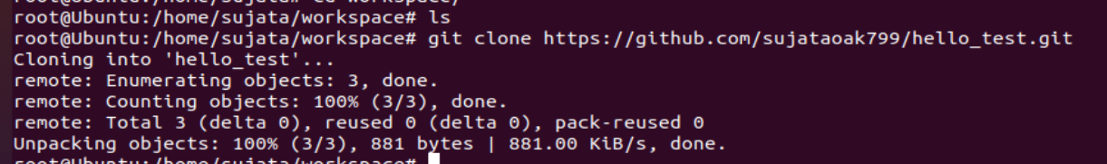



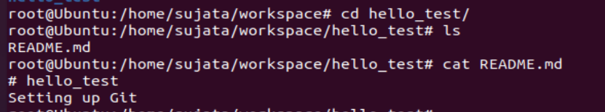

Now Create a python file hello.py in Local Repository:





*# factorial of given number*

**def** factorial(n):

**if** n < 0:

**return** 0

**elif** n == 0 **or** n == 1:

**return** 1

**else**:

fact = 1

**while**(n > 1):

fact *= n

n -= 1

**return** fact

*# Driver Code*

num = 5

print("Factorial of",num,"is",

factorial(num))

**Step 4:** Now we will apply some git commands to add, commit and push hello.py file to remote repository: Firstly To View Uncommitted File:

**#git status**

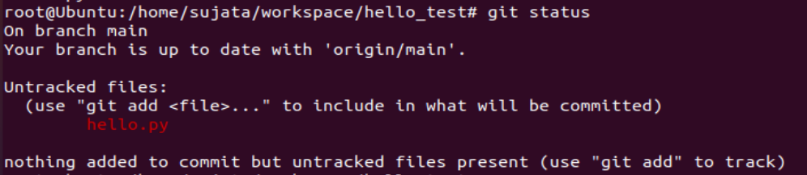

The file hello.py shown in red color is untracked (it means not tracked by git till now). So to add

to the git versioning : git add <filename>



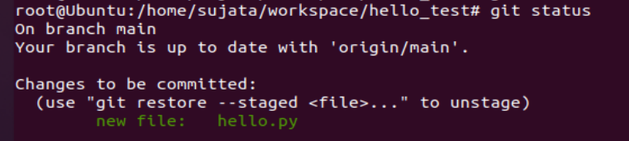

Once file is added to git, the color changes to green color. But it says changes to be committed

**Step 5**: To start first commit

git commit -m “First Python File”



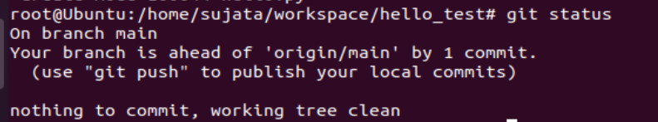

**Step 6: To Push your changes to Github Repository:**

**git push origin master or git push origin main**

#git push origin main

Enter username and password

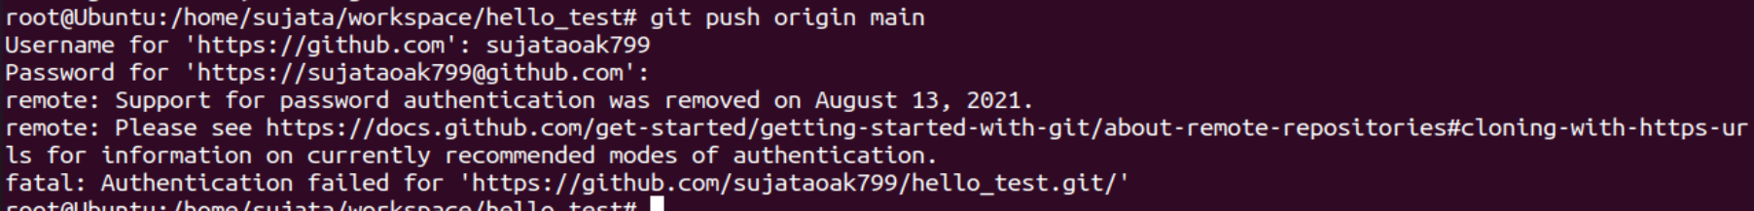

It says support for password authentication was removed on August 13, 2021.

So we need a new kind of method:

Goto your Github Account🡪User Profile🡪Settings🡪Developer Settings🡪Personal Access Token🡪Token(classic)🡪 Generate New token🡪Generate New Token(Classic)

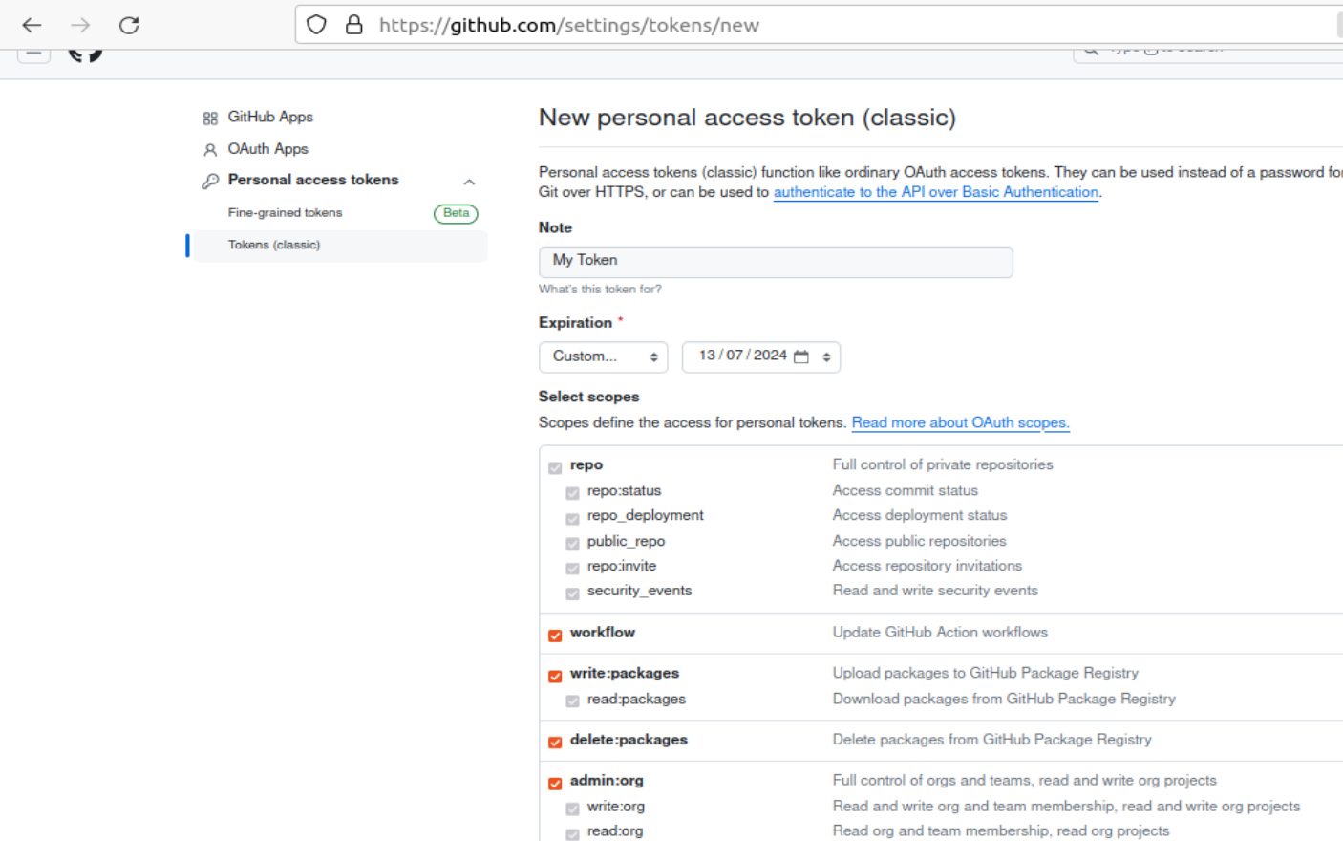

Click on Generate Token

Copy the token and paste it some location:

#git remote set-url origin https://tokenhere@github.com/user_name/repo_name



Again try to Push your changes to Github Repository:

#git push origin main

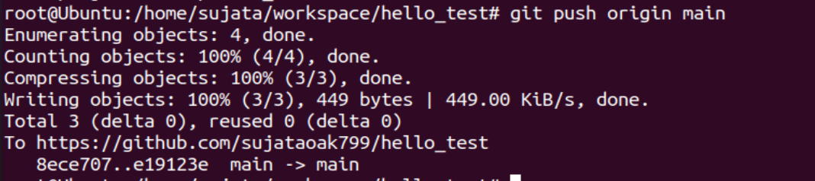

This time it is successfully implemented.

Goto Remote Repository and see the file hello.py

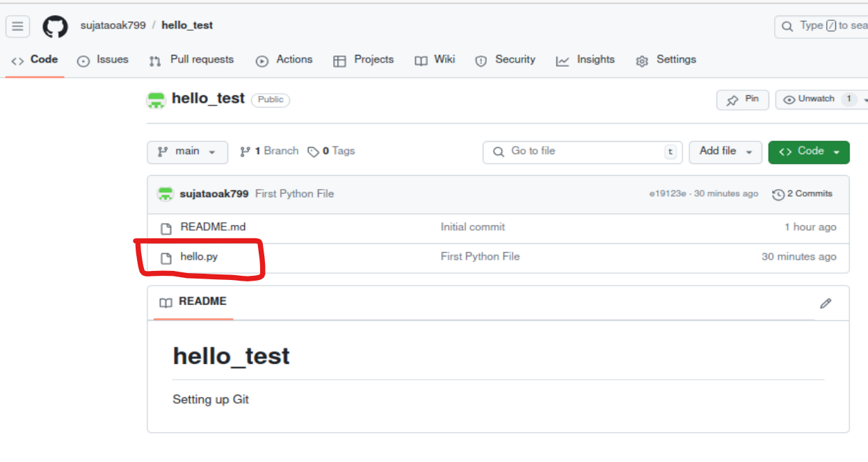

**Step7 :** To see the logs in oneline like username, email -id, date, time of creation.

git log

or

git log –oneline

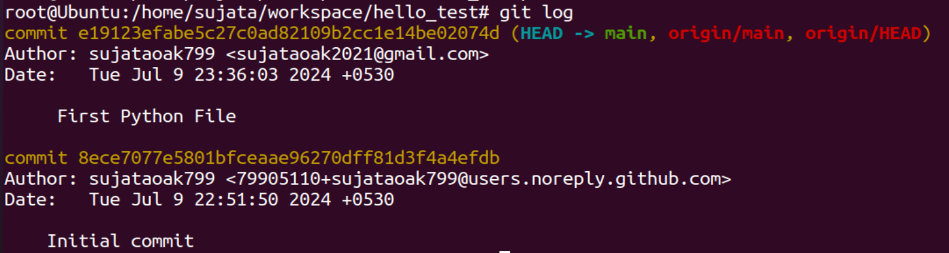

**Step 8:** To show repository id and other detail

#git show

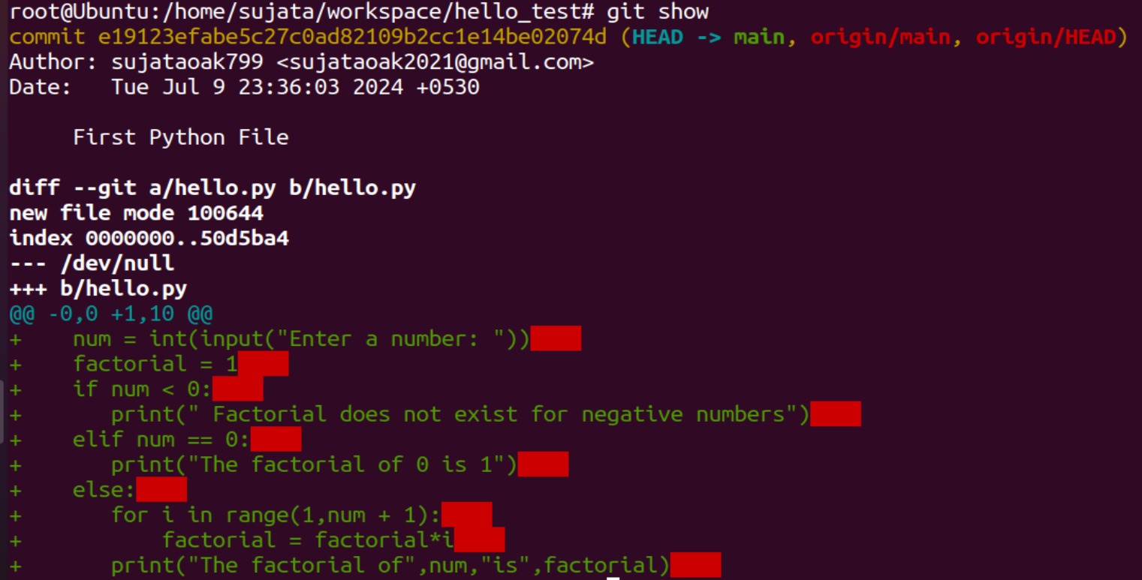

**Step 09:** To see the difference in the content of file between first and second commit.

#git diff

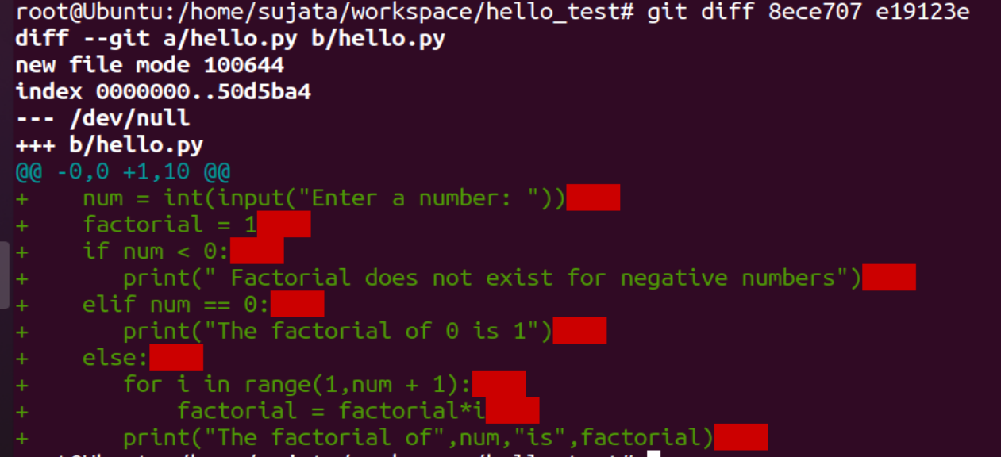

**Step 10:** Creating a latter commit and reverting back to see the initial/original content

git revert<secondcommitID>

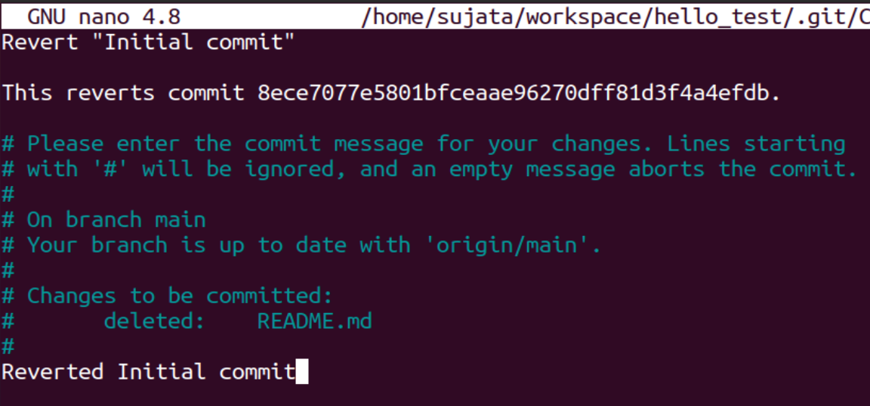

Save it

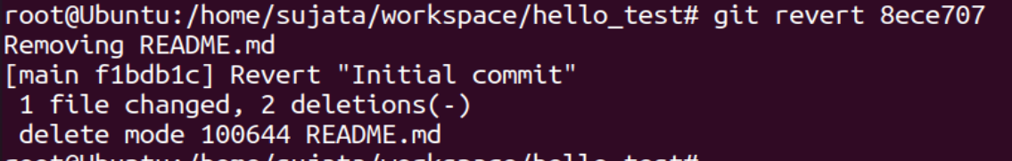

# Conclusion:

# In this experiment, we understood the use case of Version Control System, its benefits in real time scenario which provides a application of reverting the changes when people are in working in a collaborating environment. Different commands were used for the same such as revert(by using its id),diff for displaying the changes between the initial and latter texts.